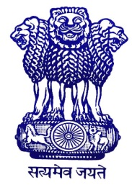

Statement by
Ambassador Venu Rajamony,
Permanent Representative of India to the OPCW
at the 57th Meeting of the Executive Council,
4 April 2018

Thank you, Mr. Chairman for giving me the floor.

India has taken note of the allegations about the recent use of chemical weapons in the United Kingdom. Any use of chemical weapons is in complete disregard of humanity, and is reprehensible and contrary to the provisions of the Chemical Weapons Convention as well as accepted international legal norms. India is against the use of chemical weapons anywhere, at any time, by anybody, under any circumstances.

The Chemical Weapons Convention (CWC) is a unique non-discriminatory multilateral instrument which continues to serve as a model disarmament treaty. It is important to maintain the credibility and integrity of the Convention. India has, therefore, maintained that all investigations of alleged use of chemical weapons should be conducted strictly in accordance with the provisions of the Convention. We also urge that all provisions of the Convention be utilised to address concerns in accordance with the procedures laid down in the Convention, so as to reach evidence based conclusions. India, as all other countries, should await the outcome of the investigation.

Mr. Chairman, I request that this Statement be circulated as an official document of this session and posted on the OPCW’s public website.

Thank you.

